Day 18 - Challenge02

Resolve Merge Conflicts
1. Create a merge conflict intentionally (two users editing the same line). Resolve the conflict and push the changes.
Commands Used in Resolving Merge Conflicts
- git branch conflictBranch - Creates a new branch named conflictBranch.
- git checkout conflictBranch - Switches from the current branch to conflictBranch.
- vi mgs.txt - Creates or edits the file mgs.txt.
- git add mgs.txt - Stages the file before committing.
- git commit -m "Commit message" - Saves the staged changes to the local repository.
- git checkout main - Switches back to the main branch.
- git merge conflictBranch - Merges the conflictBranch into the main branch. Since both branches modified the same line, Git generated a merge conflict.
- git status - Displays the current status of the repository and indicates whether there are merge conflicts.
- git add mgs.txt - Stages the file after resolving the merge conflict.
- git commit -m "Resolved merge conflict" - Commits the resolved merge conflict.
- git pull origin main - Retrieves and merges the latest changes from the remote repository into the local main branch.
- git push origin main - Pushes the final resolved changes from the local repository to the remote GitHub repository.

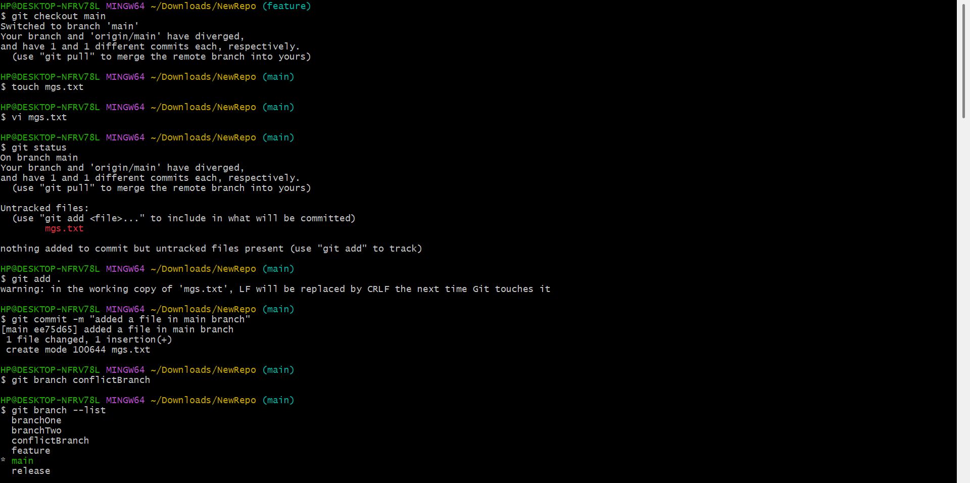
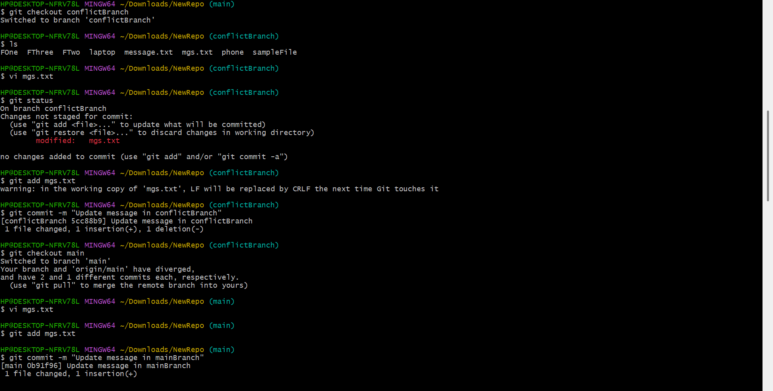
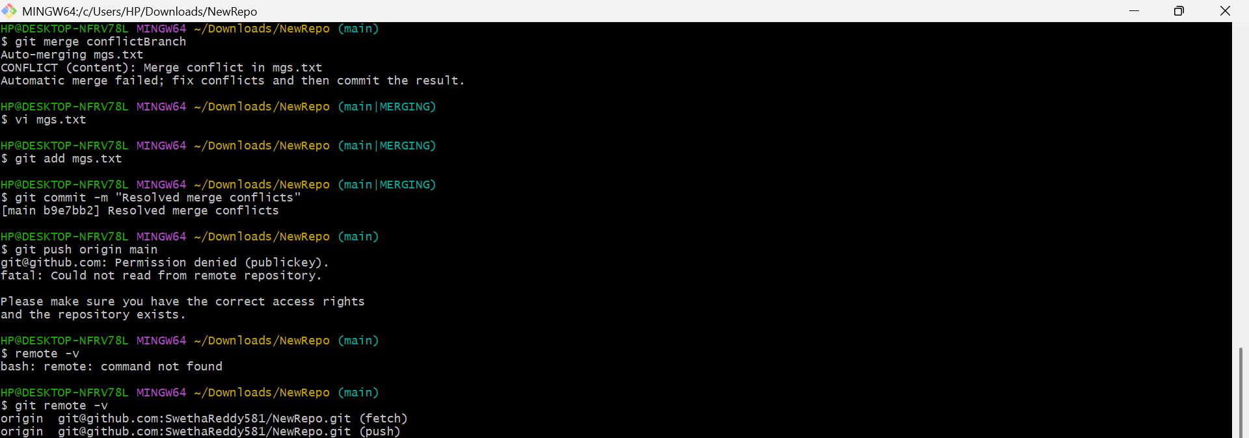
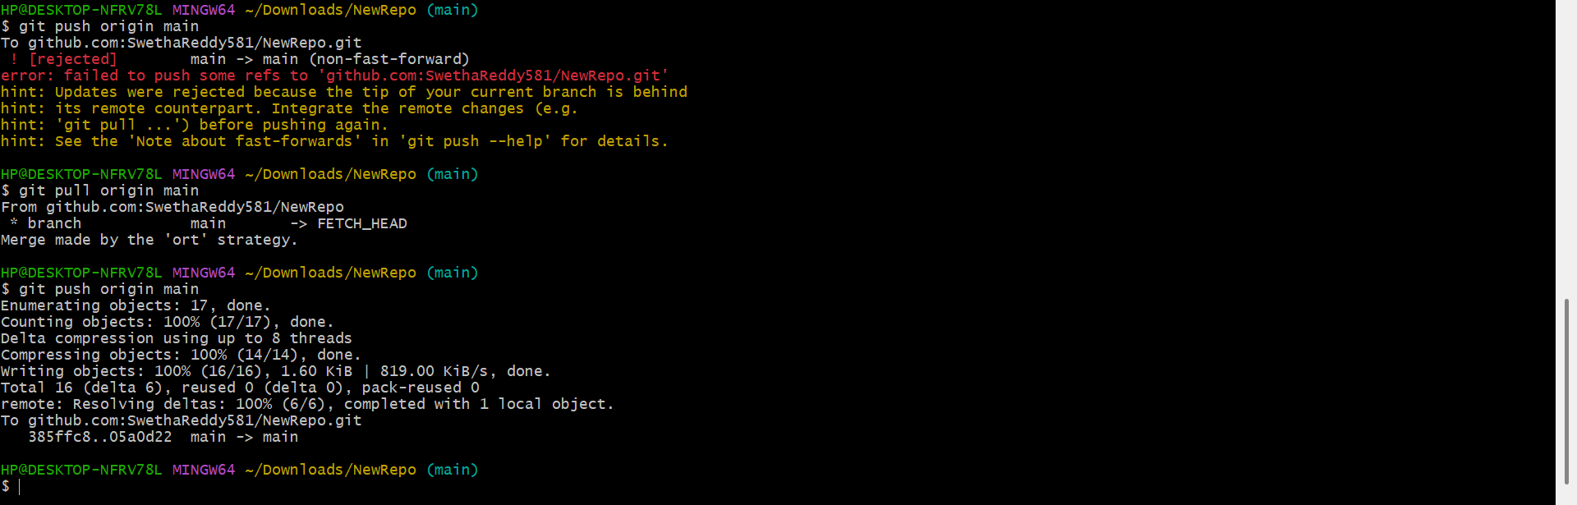

Recover Deleted Branch
2. Delete a local branch and then recover it using the reflog.
- git branch -D <branch_name> - Used to delete a branch forcefully(incase if it’s not fully merged)
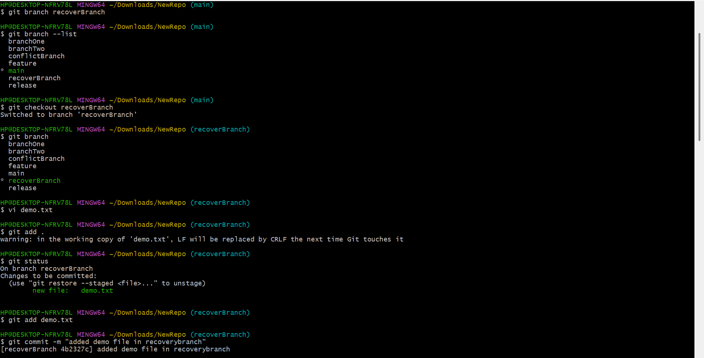
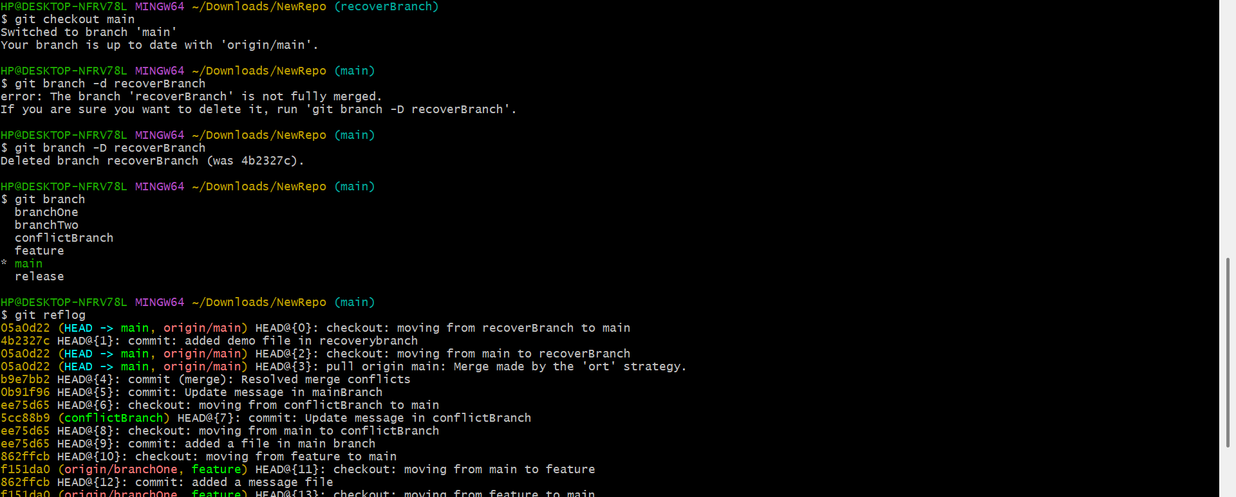
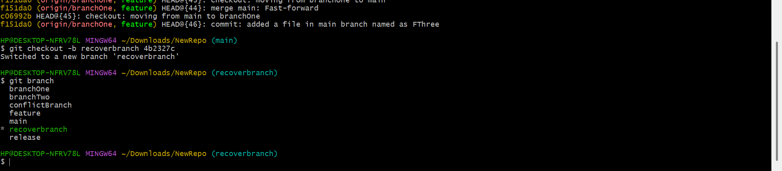
Undo Wrong Push
3. Push a wrong commit to GitHub, then undo it without losing history.
- git status – Checks the current status of the repository.
- git add <file-name> – Stages the modified file.
- git commit -m "Wrong update" – Creates a commit with the changes.
- git push origin main – Pushes the commit to the remote GitHub repository.
- git revert HEAD – Reverts the last commit by creating a new commit without deleting history.
- git push origin main – Pushes the revert commit to the remote repository.
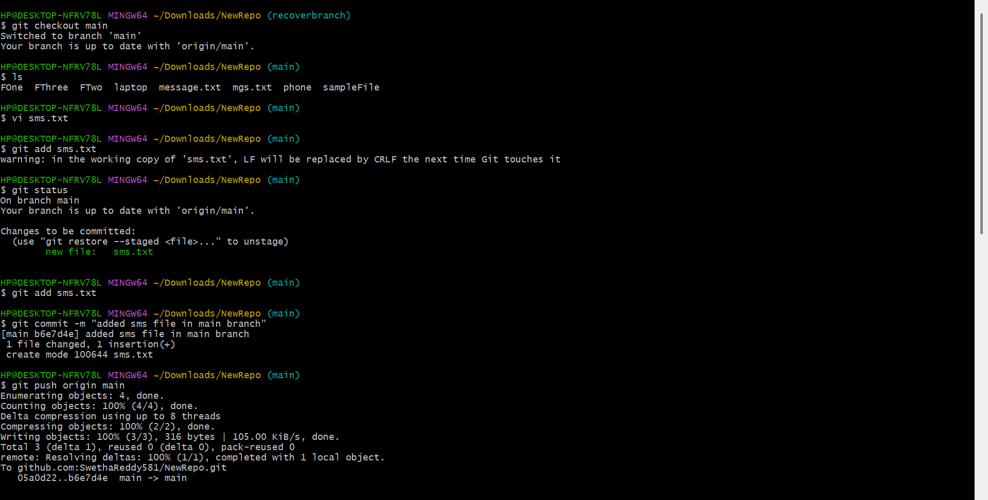
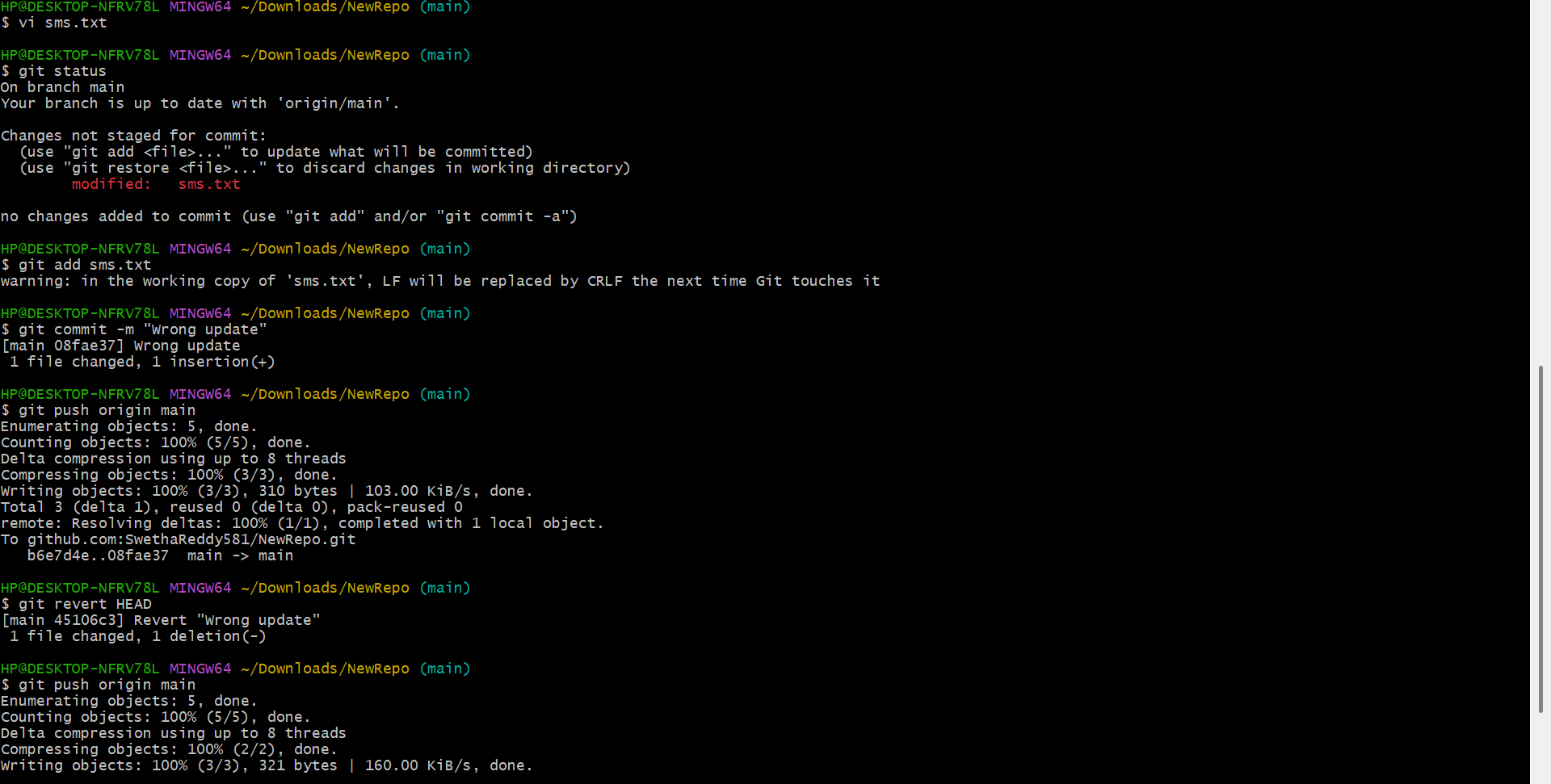
Amend a Commit
4. Make a commit, then add a missing file to it usinggit commit --amend.
- git checkout release – Switches to the release branch.
- touch aOne – Creates the first file.
- touch aTwo – Creates the second file.
- git add aOne – Stages the first file.
- git commit -m "Added aOne file in release branch" – Creates the initial commit.
- git add aTwo – Stages the forgotten file.
- git commit --amend – Updates the most recent commit by including the missing file instead of creating a new commit.
- git log --oneline – Verifies that the latest commit has been amended.
- git push origin release (optional) – Pushes the amended commit to the remote repository if required.
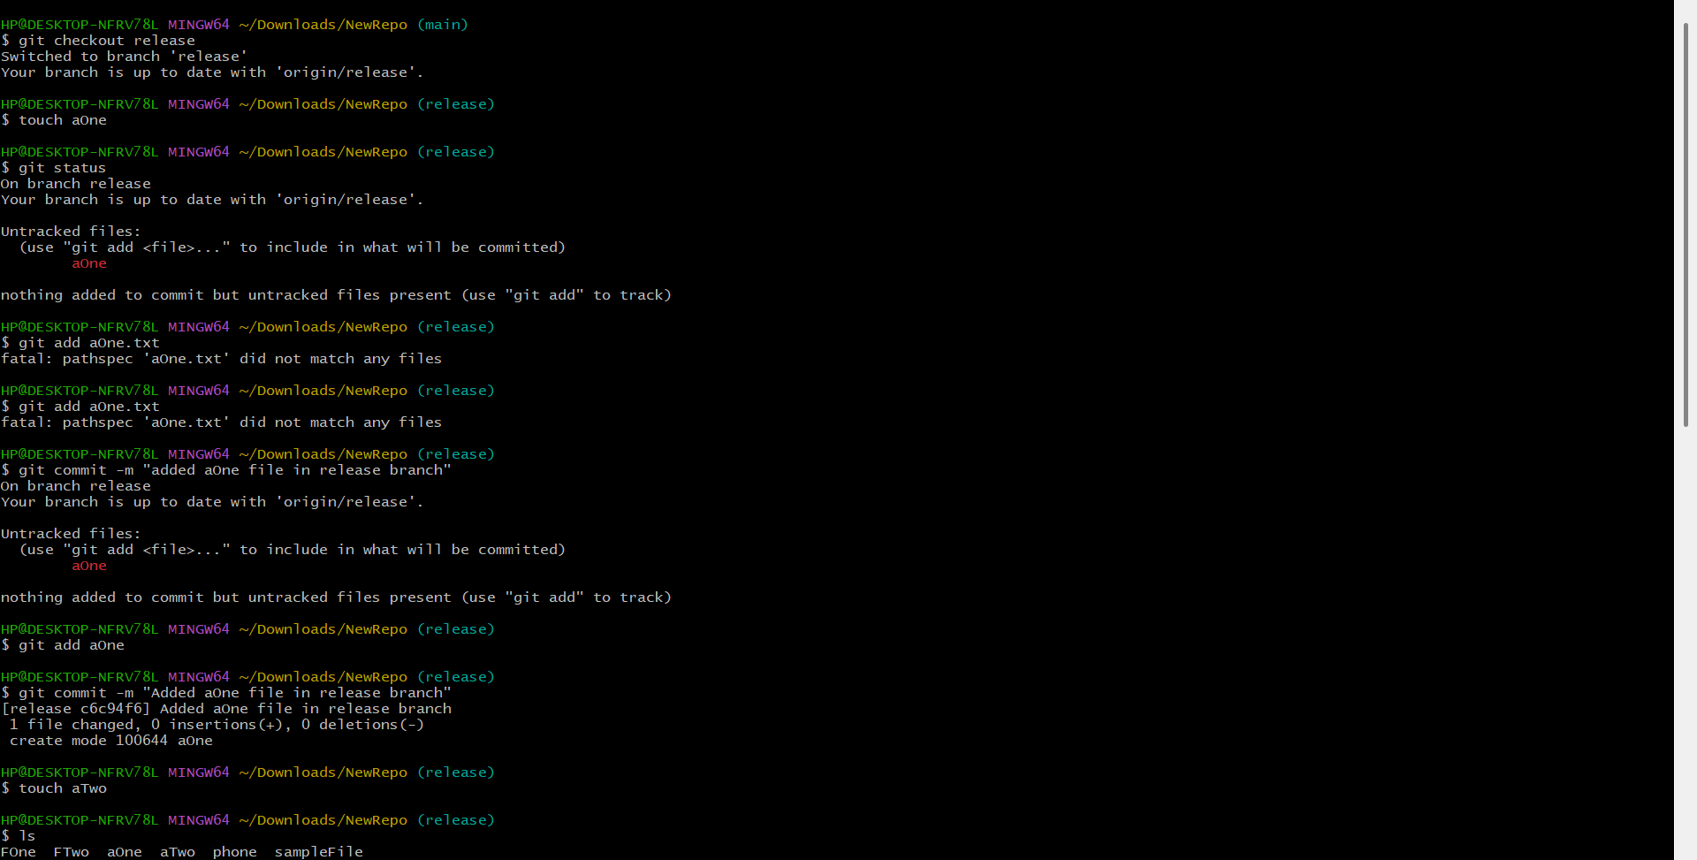
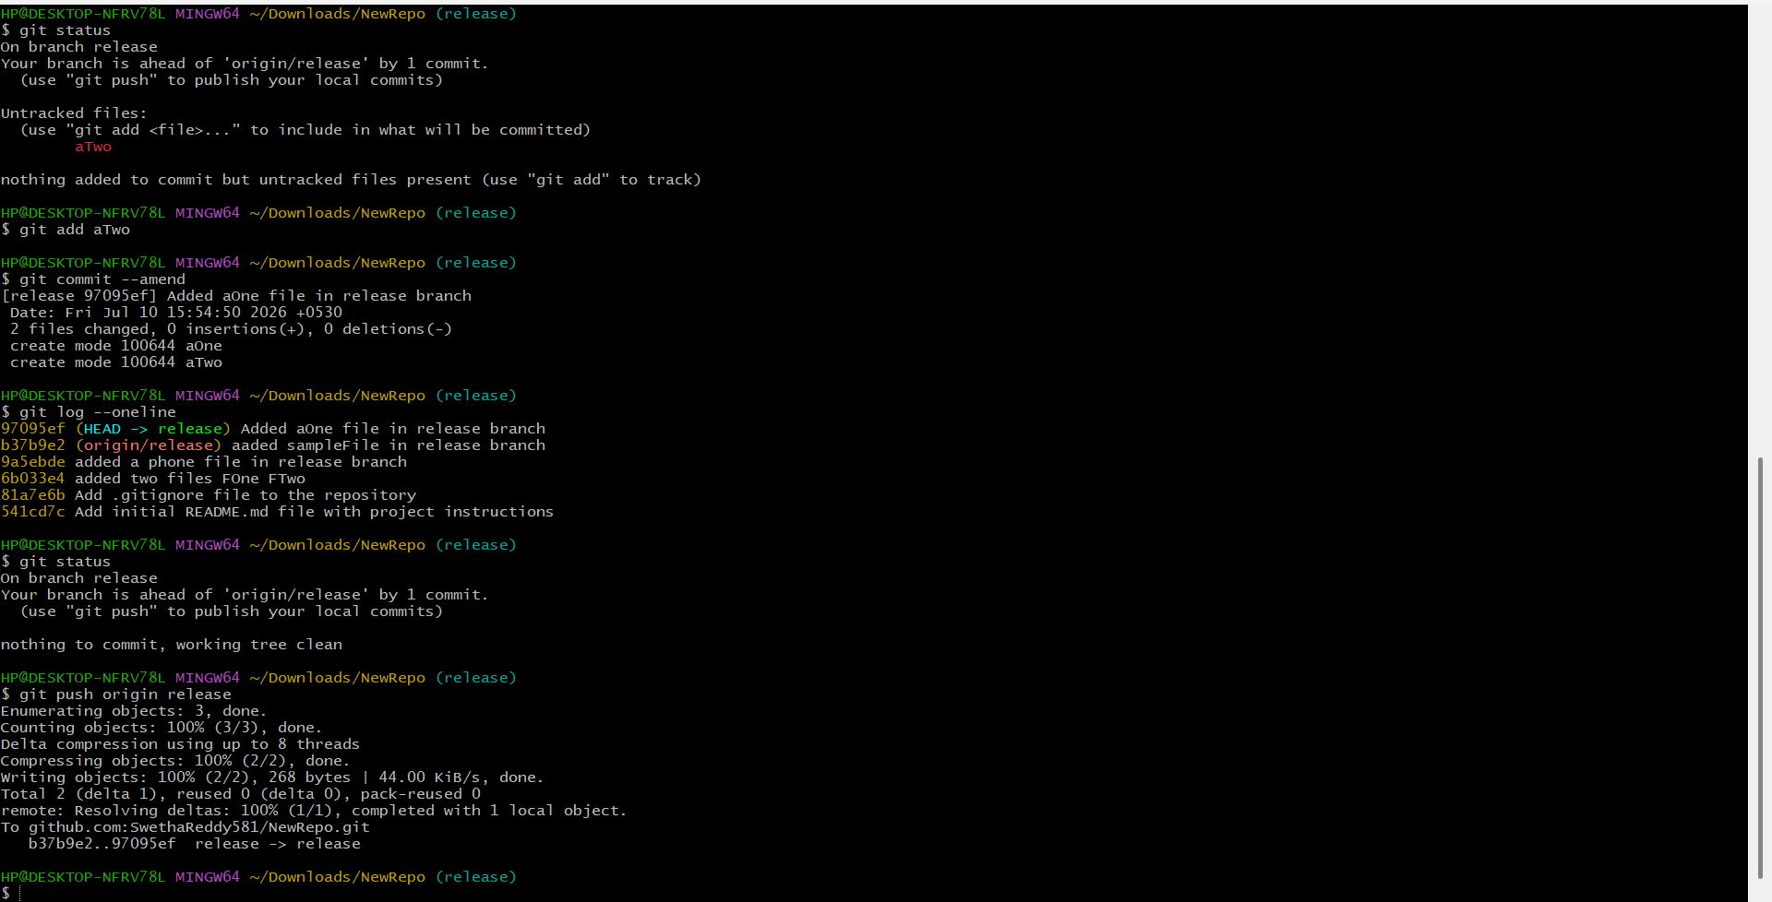
Cherry-pick a Commit
5. Take a specific commit from one branch and apply it to another branch.
- git checkout feature – Switches to the source branch.
- touch word – Creates a new file.
- git add word – Stages the file.
- git commit -m "Added word file in feature branch" – Creates a commit on the source branch.
- git log --oneline – Displays the commit history to obtain the commit ID.
- git checkout conflictBranch – Switches to the destination branch.
- git cherry-pick <commit-id> – Copies the selected commit from the source branch and applies it to the current branch.
- git log --oneline – Verifies that the cherry-picked commit has been added to the destination branch.
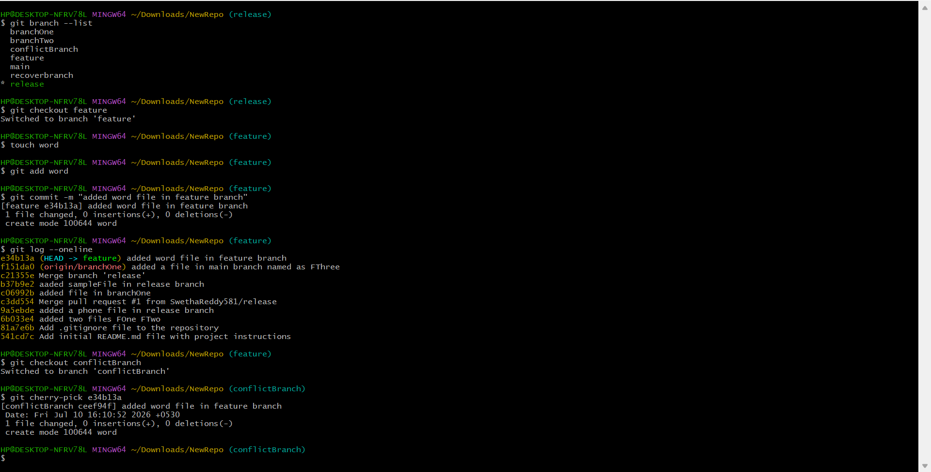
Interactive Rebase
6. Reorder and squash multiple commits into a single clean commit.
- git checkout release – Switches to the release branch.
- touch <file-name> – Creates new files for making multiple commits.
- git add <file-name> – Stages the files for committing.
- git commit -m "<message>" – Creates separate commits.
- git log --oneline – Displays the commit history.
- git rebase -i HEAD~3 – Starts an interactive rebase for the last three commits.
- pick – Keeps a commit unchanged during rebase.
- squash (or s) – Combines the selected commit with the previous commit into a single commit.
- git log --oneline – Verifies that multiple commits have been combined into one clean commit.

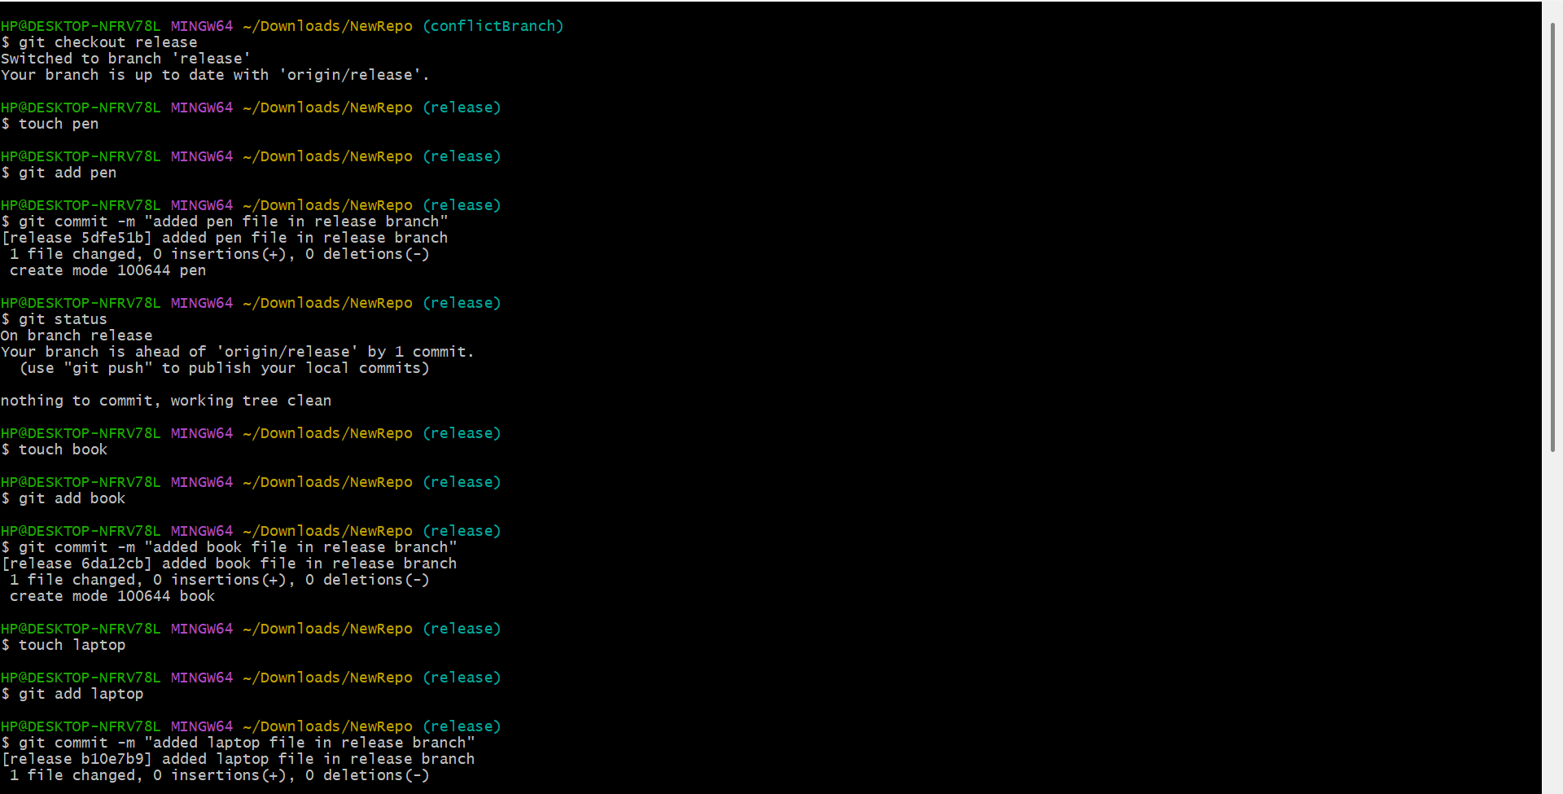
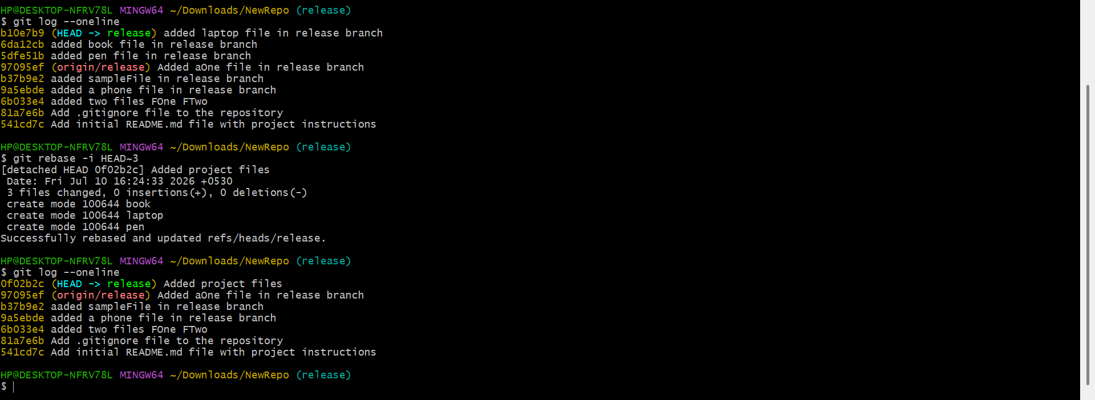
Tagging & Release
7. Create a version tag (v1.0), push it to GitHub, then delete and restore it.
- git checkout main – Switches to the main branch.
- git tag v1.0 – Creates a version tag named v1.0.
- git tag – Lists all local tags.
- git push origin v1.0 – Pushes the tag to the remote GitHub repository.
- git tag -d v1.0 – Deletes the tag from the local repository.
- git fetch --tags – Restores the deleted local tag by fetching all tags from the remote repository.
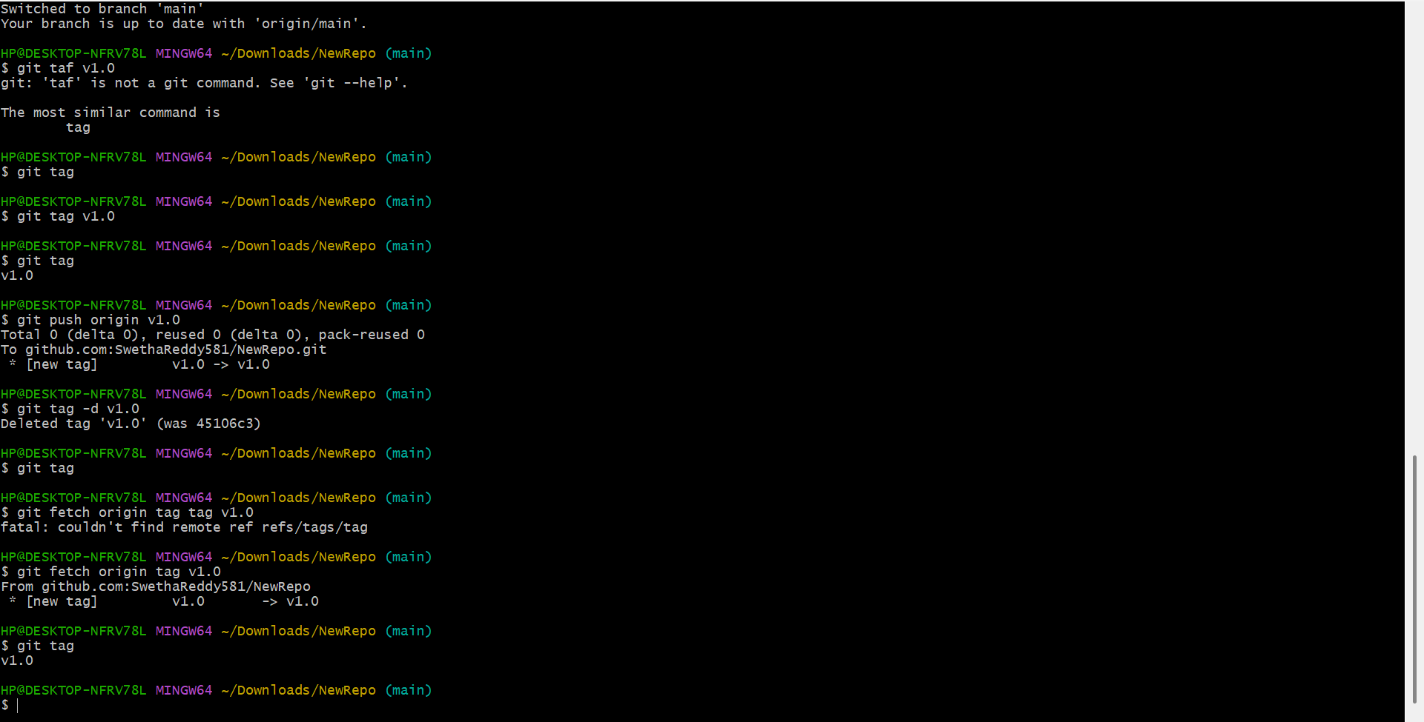
Clone with Sparse Checkout
8. Clone only a subdirectory of a repo using sparse checkout.
- git clone --no-checkout <repository-url> – Clones the repository without checking out the files.
- cd <repository-name> – Moves into the cloned repository.
- git sparse-checkout init --cone – Enables sparse checkout in cone mode.
- git sparse-checkout set docs – Checks out only the docs directory.
- git checkout main – Switches to the main branch and applies the sparse checkout.
- ls – Verifies that only the selected directory is available in the working directory.

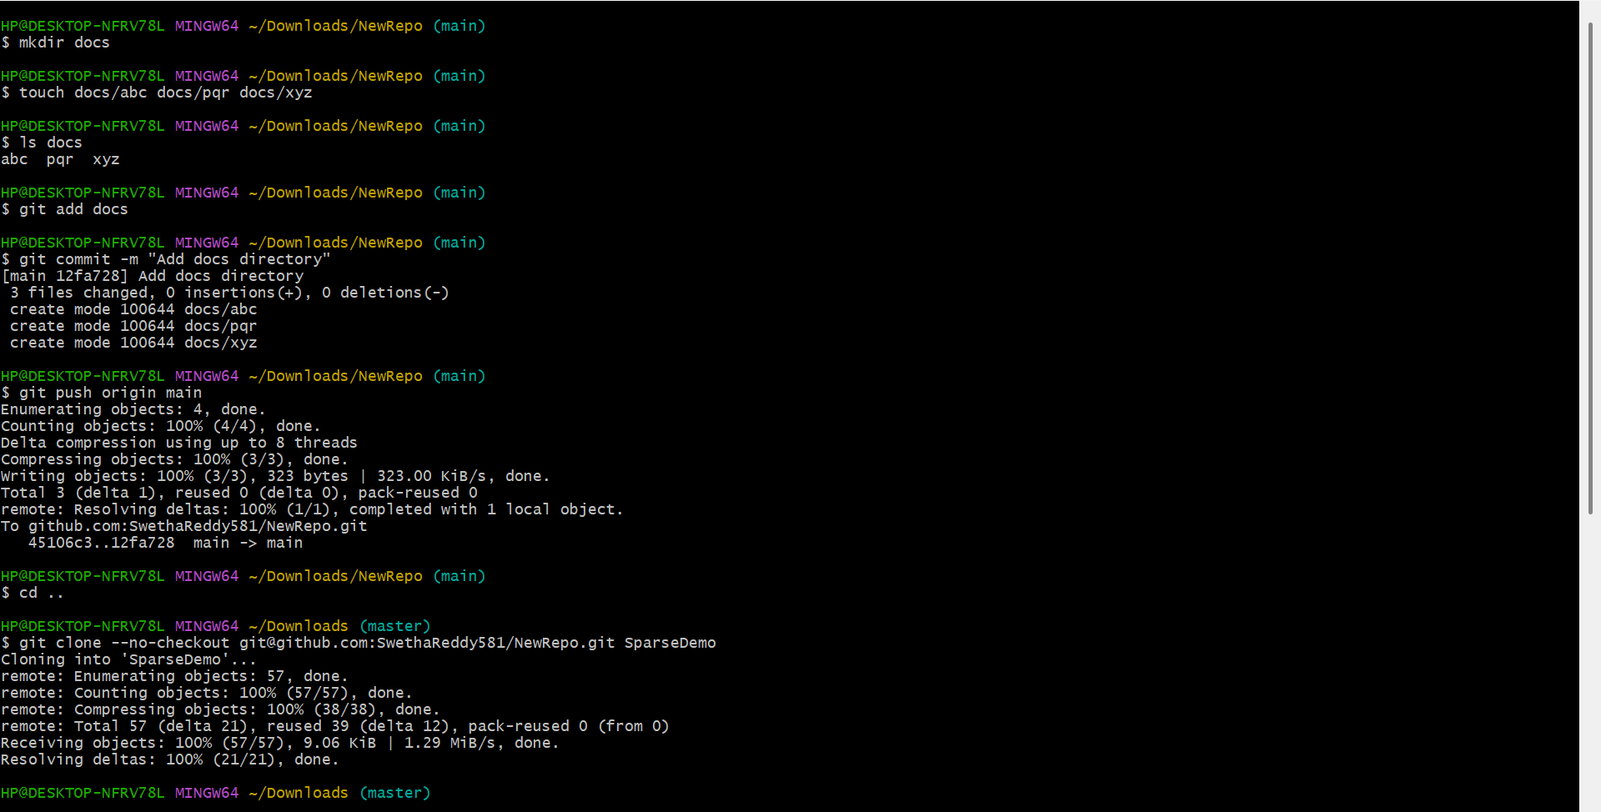
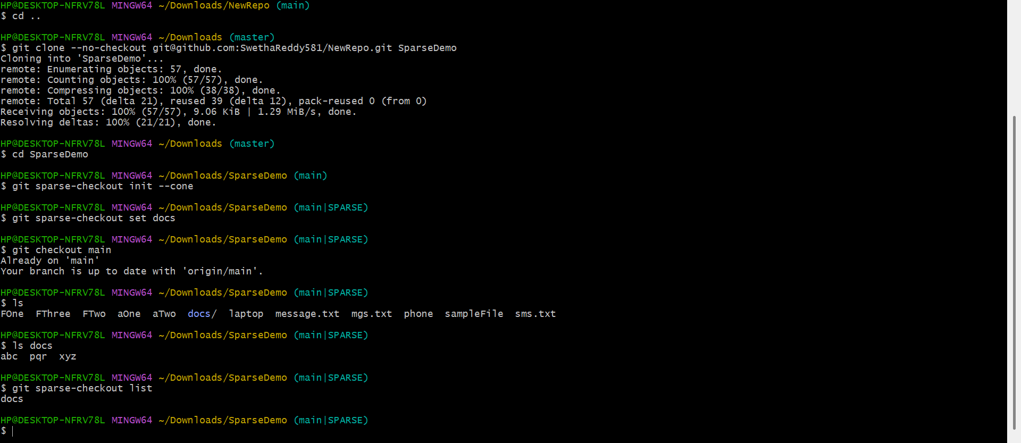
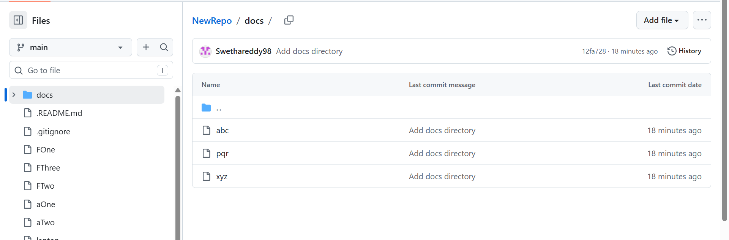

Reset vs Revert Challenge
9. Demonstrate the difference betweengit reset --hardandgit revertin a repo.
- git add <file-name> – Stages the modified files for committing.
- git commit -m "<message>" – Creates a commit with the staged changes.
- git log --oneline – Displays the commit history in a compact format.
- git reset --hard HEAD~1 – Removes the latest commit and resets the working directory to the previous commit.
- git revert HEAD – Creates a new commit that undoes the changes made by the latest commit while preserving the commit history.
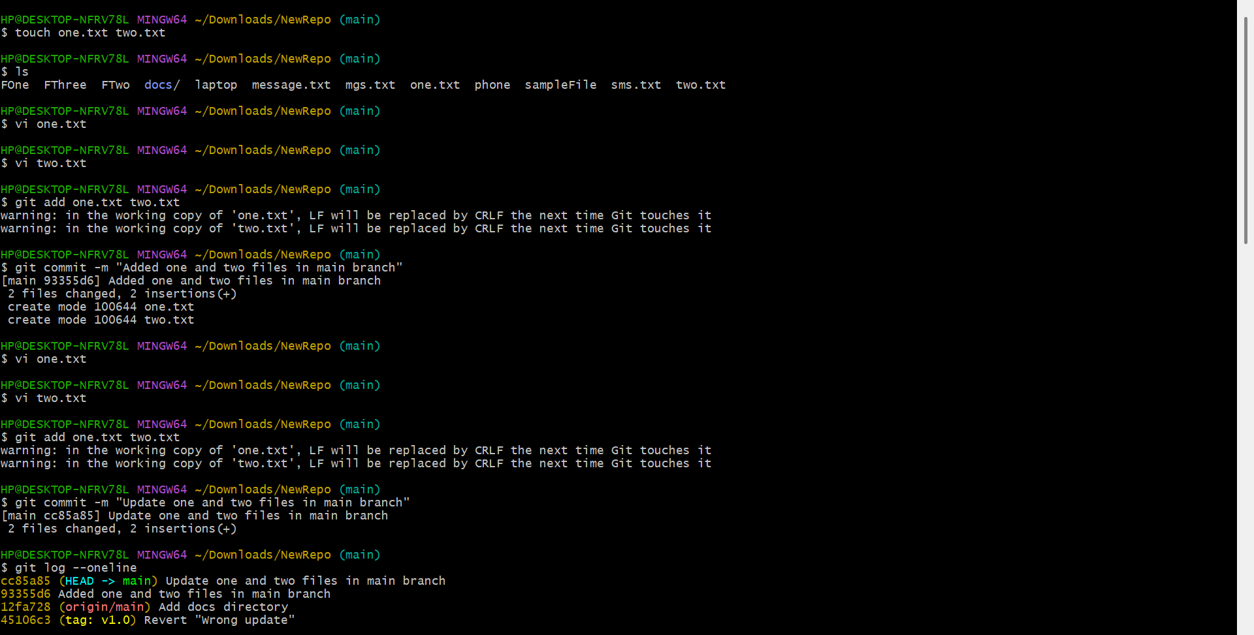
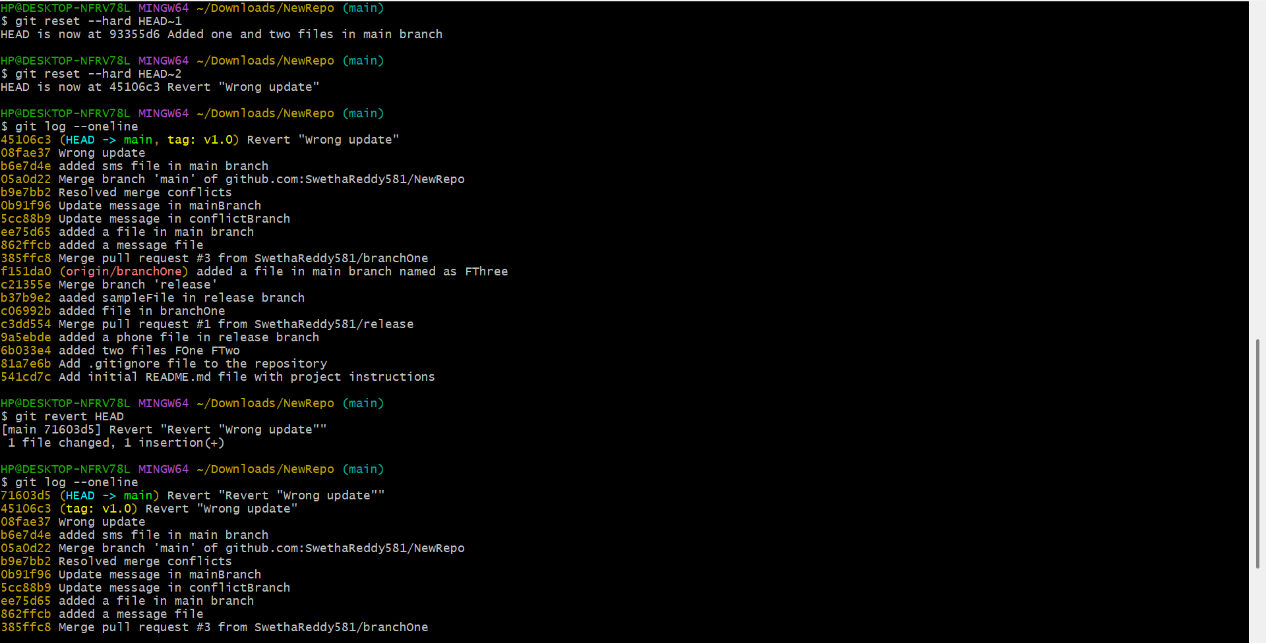
Detached HEAD Challenge
10. Checkout a specific commit (detached HEAD state) and create a new branch from it.
- git checkout main – Switches to the main branch.
- git log --oneline – Displays the commit history and commit IDs.
- git checkout <commit-id> – Checks out a specific commit and enters the Detached HEAD state.
- git branch – Shows the current branch or confirms the Detached HEAD state.
- git checkout -b <branch-name> – Creates a new branch from the checked-out commit and switches to it.
- git branch – Verifies that the new branch has been created and is the current branch.
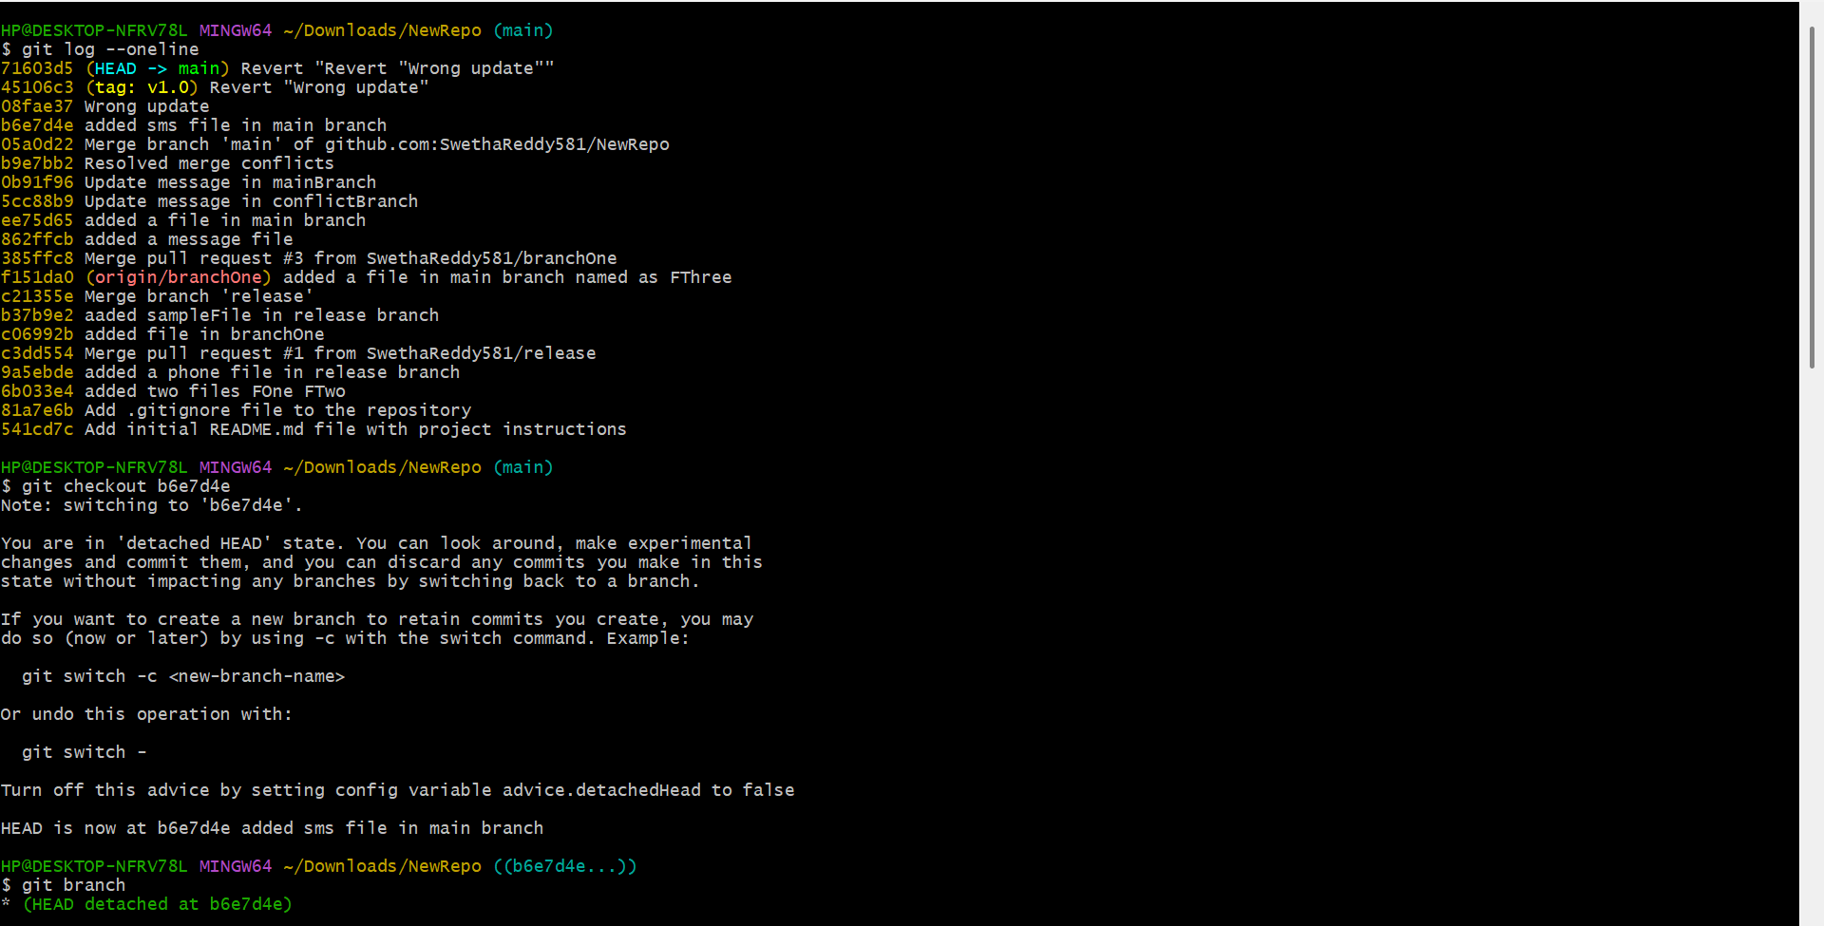
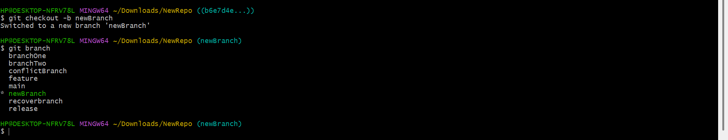
Git Hooks Challenge
11. Configure a pre-commithook to reject commits without a message format (e.g., must start withJIRA-XXX).
- cd .git/hooks – Navigates to the Git hooks directory.
- touch commit-msg – Creates the commit-msg hook file.
- vi commit-msg – Opens the hook file to add the commit message validation script.
- chmod +x commit-msg – Makes the hook executable.
- git add <file-name> – Stages the file for committing.
- git commit -m "JIRA-101 <message>" – Creates a commit with a valid message that satisfies the hook's required format.
- git commit -m "<message>" – Demonstrates an invalid commit message, which is rejected by the hook because it does not start with JIRA-<number>.
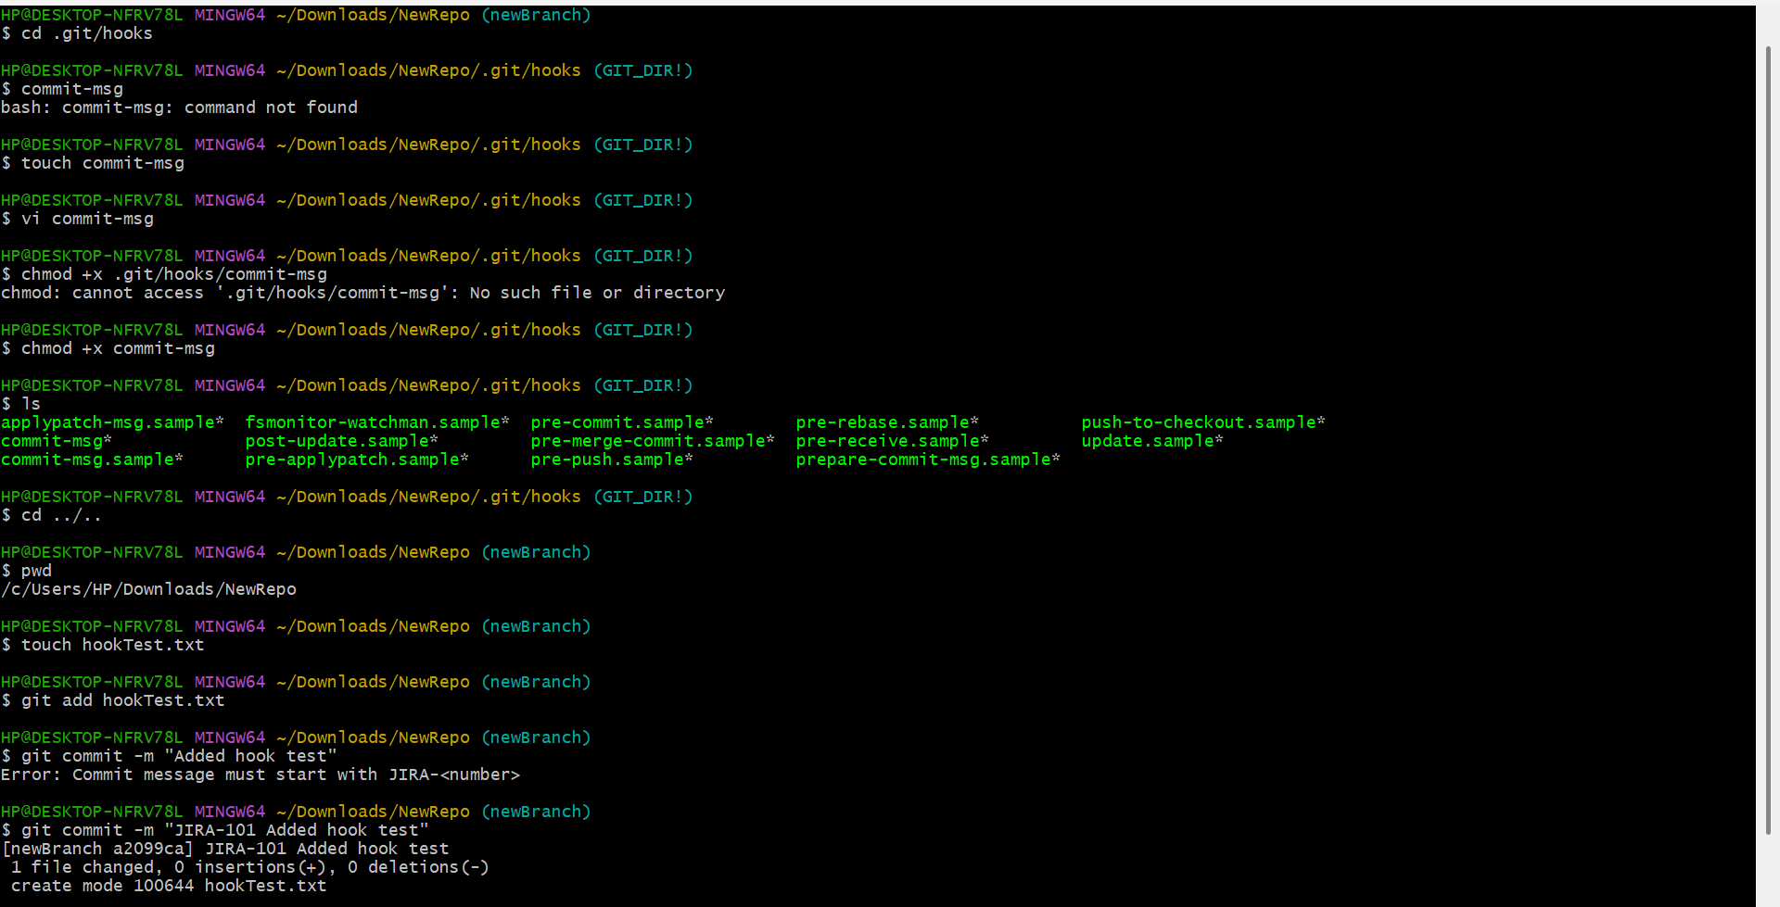
Squash Merge vs Rebase Merge
12. Show the difference between squash merge and rebase merge with evidence.
- git checkout -b <branch-name> – Creates and switches to a new branch.
- git add <file-name> – Stages the file for committing.
- git commit -m "<message>" – Creates a new commit with the staged changes.
- git merge --squash <branch-name> – Combines all commits from the specified branch into a single staged change.
- git rebase main – Replays the current branch's commits on top of the latest main branch, creating a linear history.
- git merge <branch-name> – Merges the rebased branch into the current branch.
- git log --oneline --graph – Displays the commit history in a compact graphical format to compare squash merge and rebase merge results.
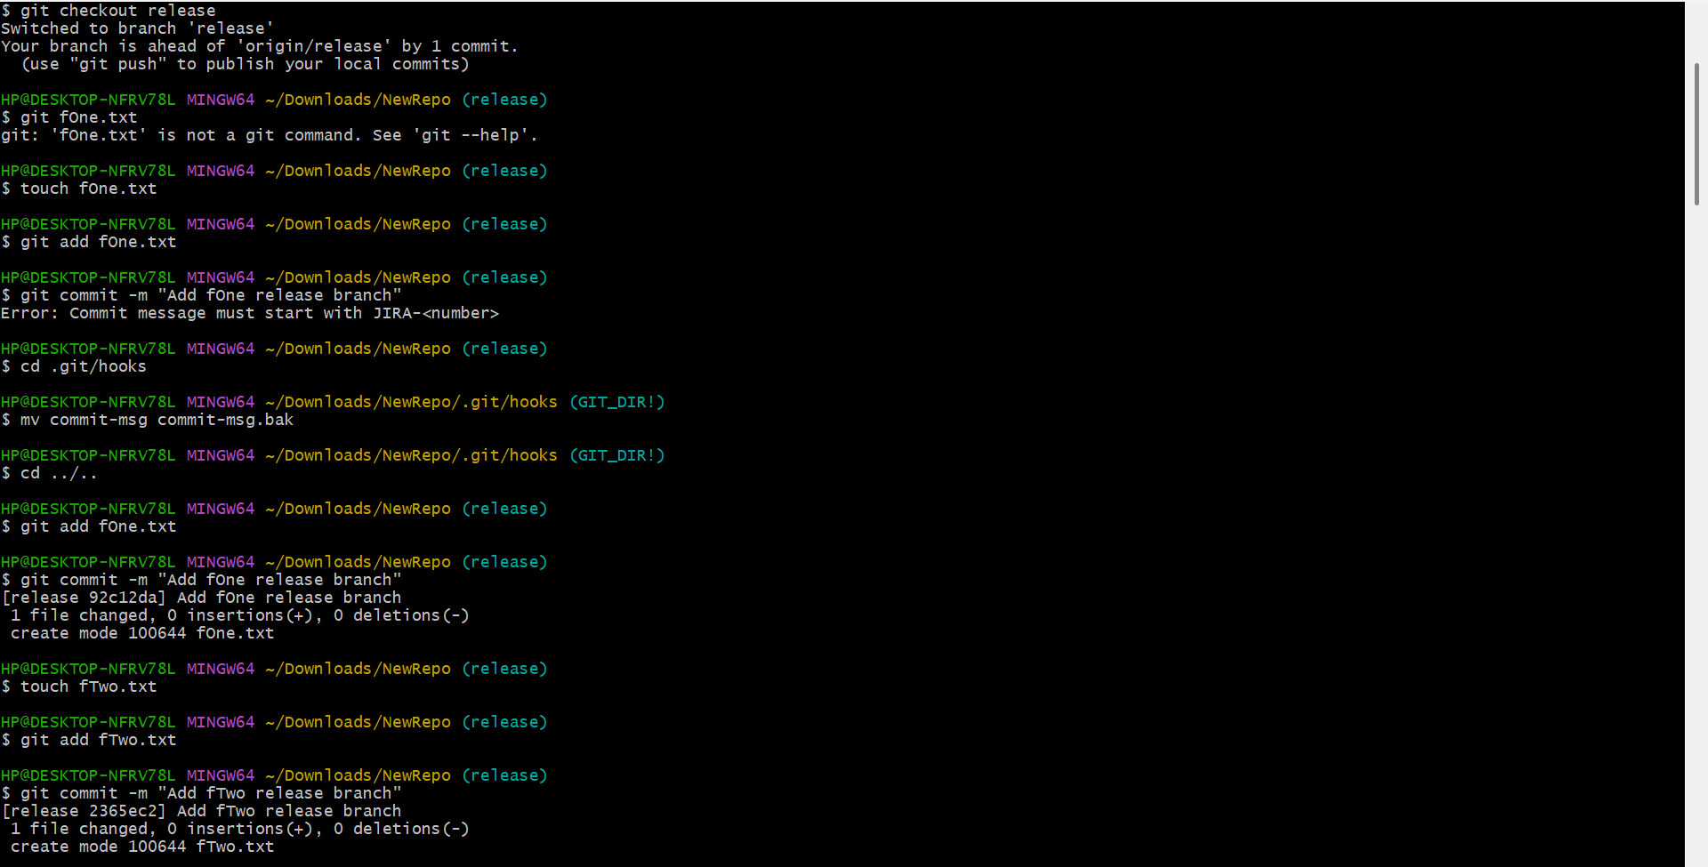
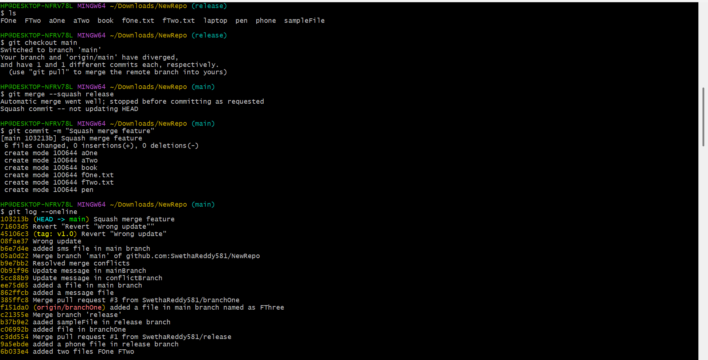
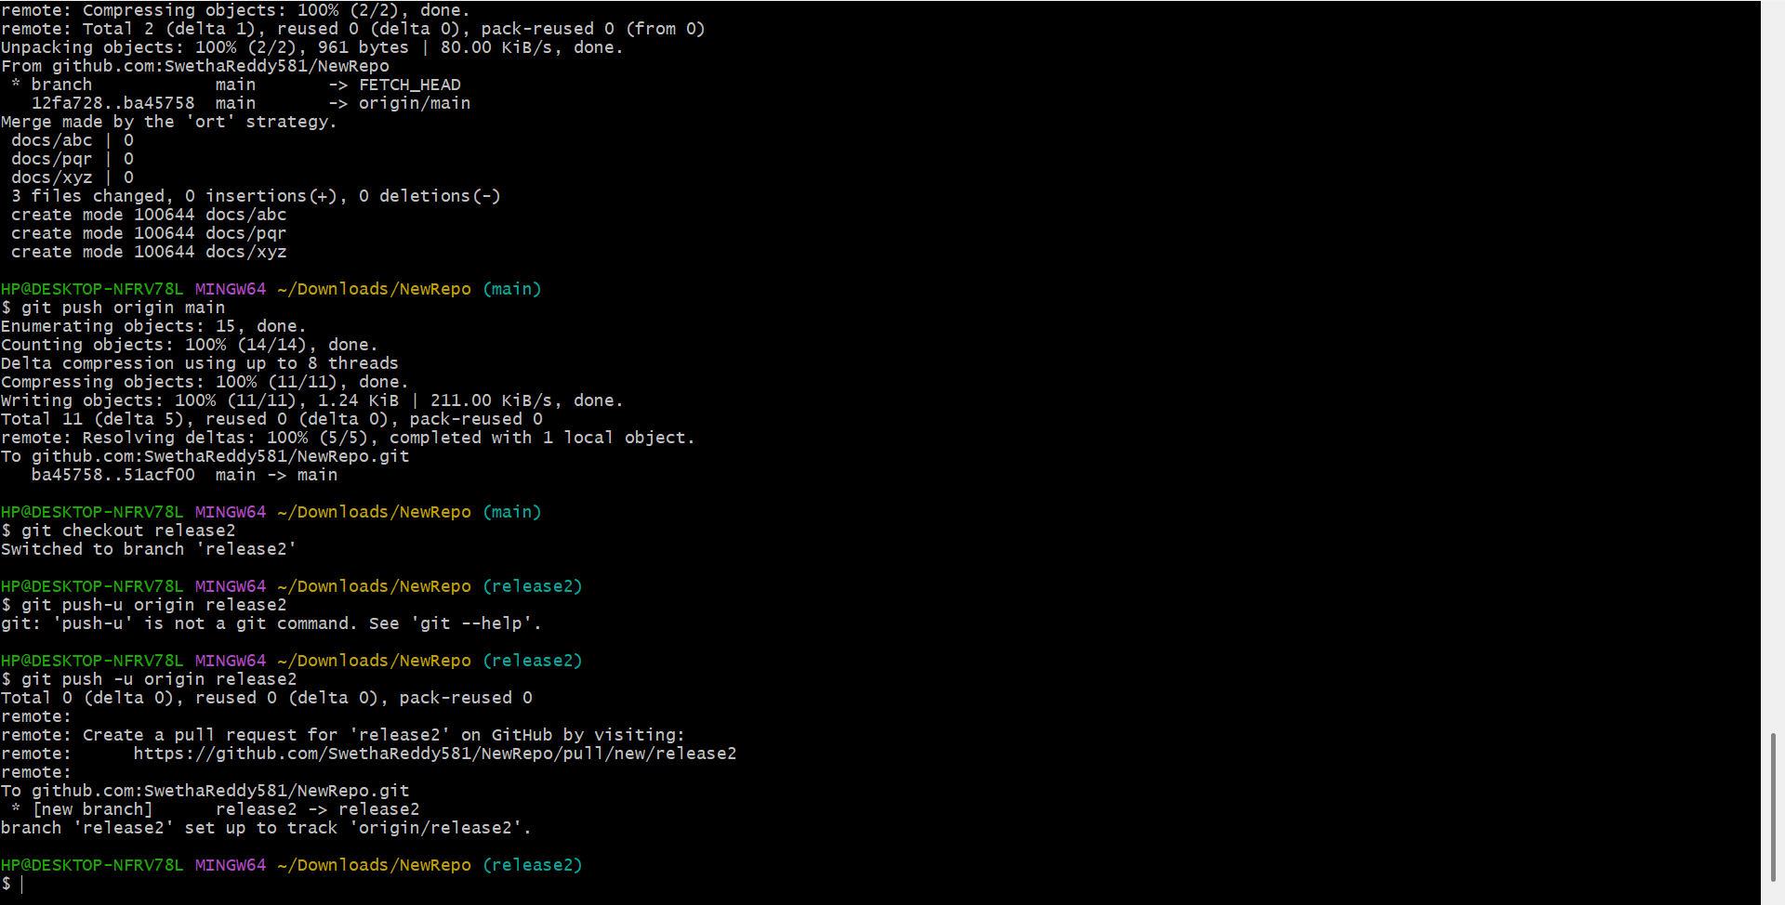
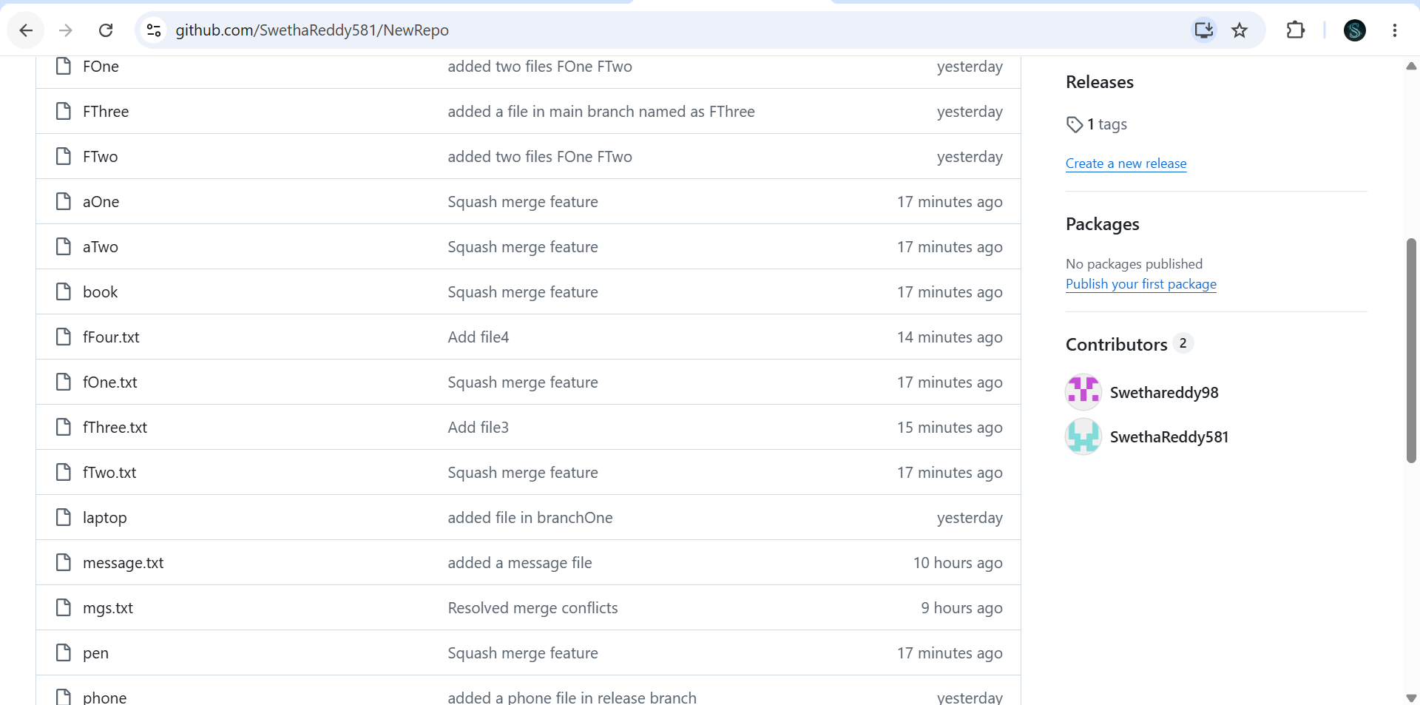
Fork & Pull Request Workflow
13. Fork a repo, make a change, and submit a pull request to the original repo.
- git clone <repository-url> – Clones the forked repository to your local machine.
- git checkout -b <branch-name> – Creates and switches to a new branch.
- git add . – Stages all modified files.
- git commit -m "<message>" – Creates a commit with your changes.
- git push -u origin <branch-name> – Pushes the new branch to your fork on GitHub.
- Fork (GitHub) – Creates your own copy of another user's repository.
- Pull Request (GitHub) – Requests the original repository owner to review and merge your changes.
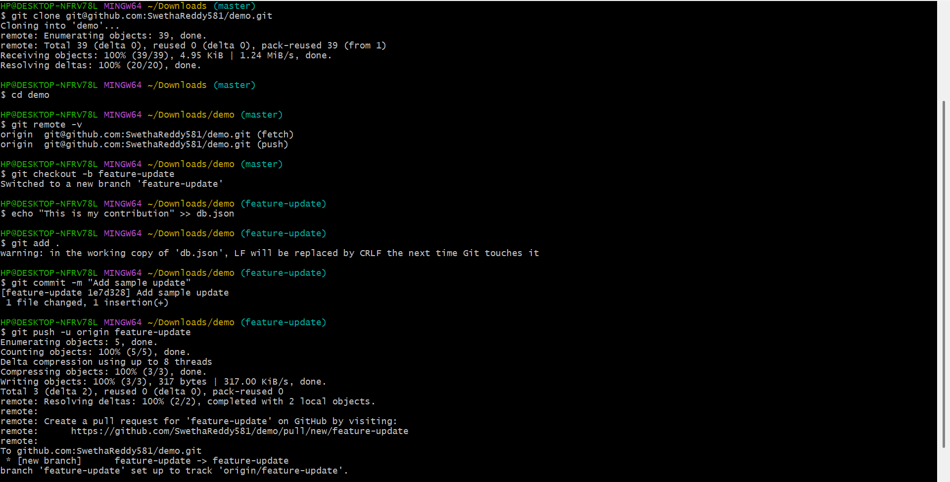
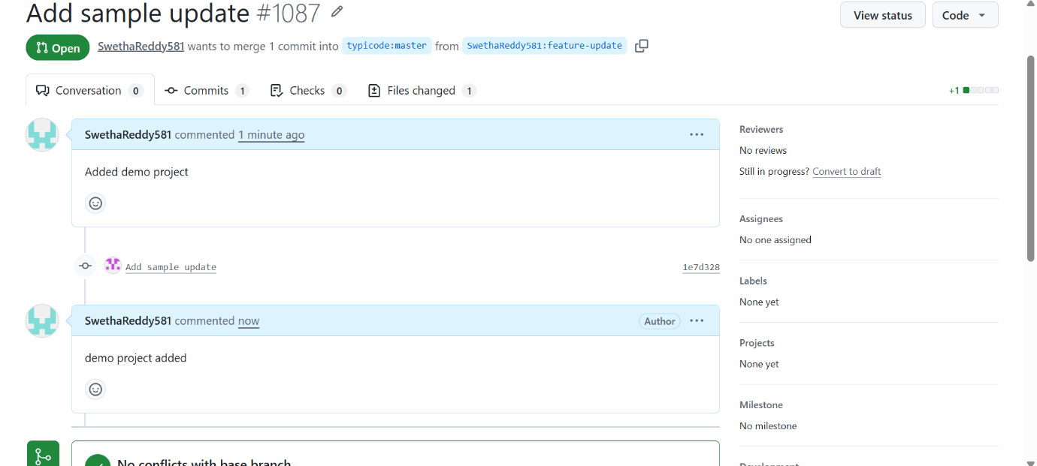
Recover Lost Commit
14. Commit something, reset hard, and then recover it using git reflog.
- git checkout main – Switches to the main branch.
- git add <file> – Stages the file.
- git commit -m "<message>" – Creates a new commit.
- git reset --hard HEAD~1 – Removes the latest commit.
- git reflog – Shows the history of recent Git actions.
- git reset --hard <commit-hash> – Restores the lost commit.
- git log --oneline – Verifies that the commit has been recovered.
